- Create a files in vi editor [ Command : vi f1 f2 ]
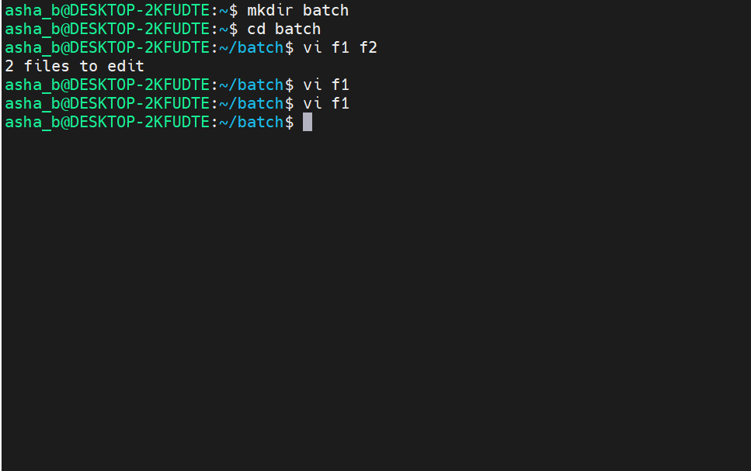

- Press i [ To insert a content inside f1 ]
- esc:set nu [ To add line number ]
- esc:wq [ To save and quit file ]

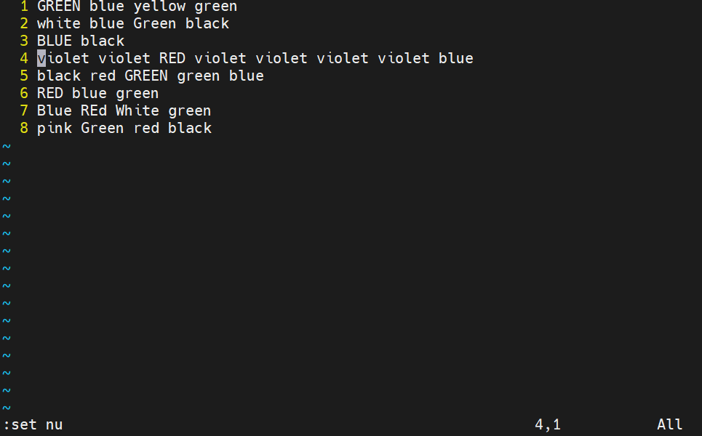
- Execute the command : esc:4s/violet/green
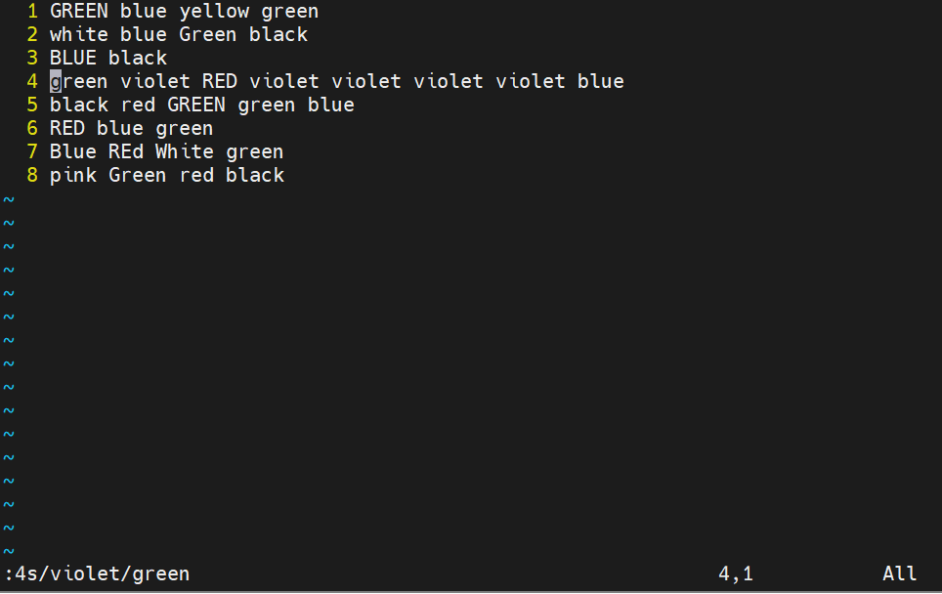

- Execute the command : esc:4s/violet/Rose/g
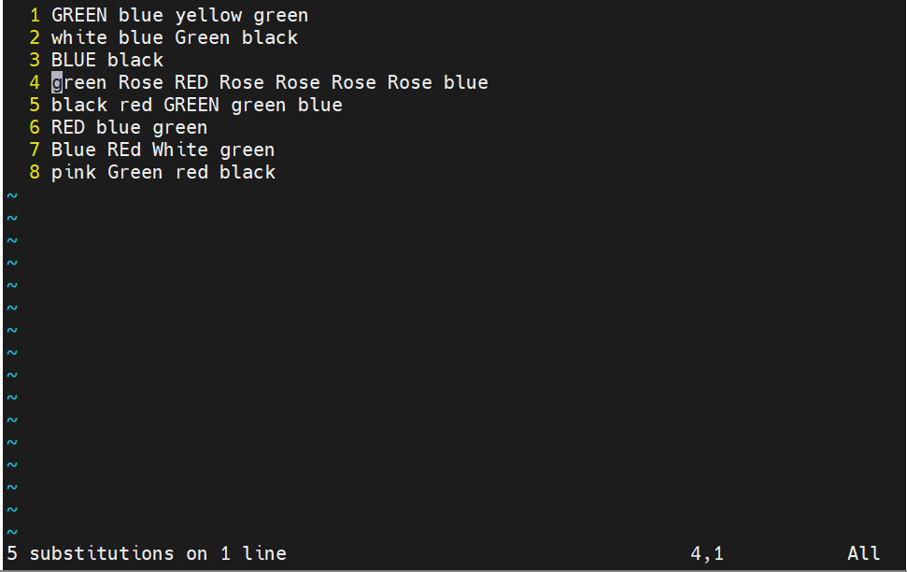

- Execute the command : esc:1,5s/GREEN/ORANGE
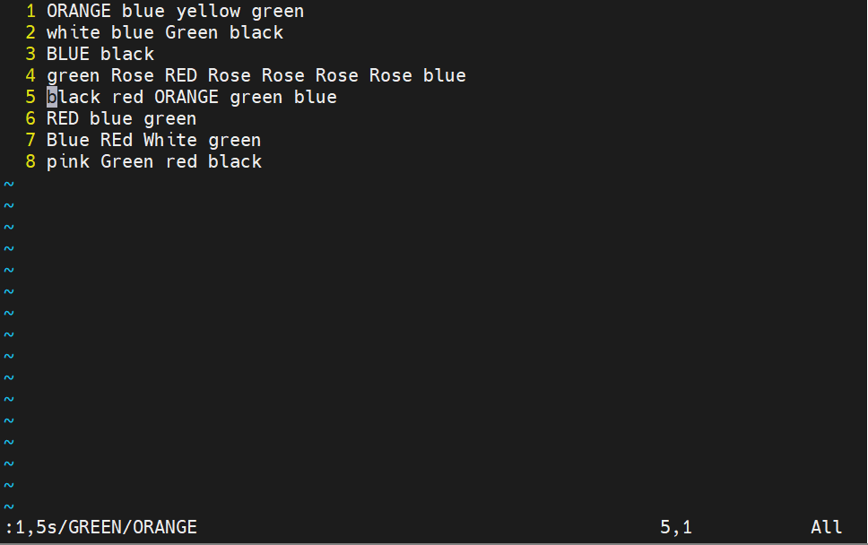

- Execute the command : esc:1,$s/green/brown/g
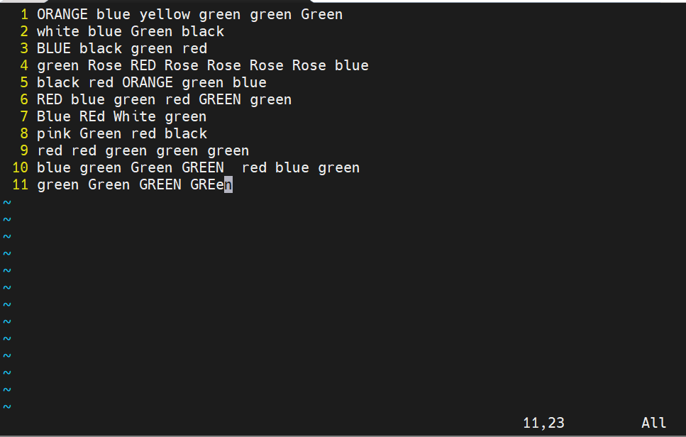

Output :
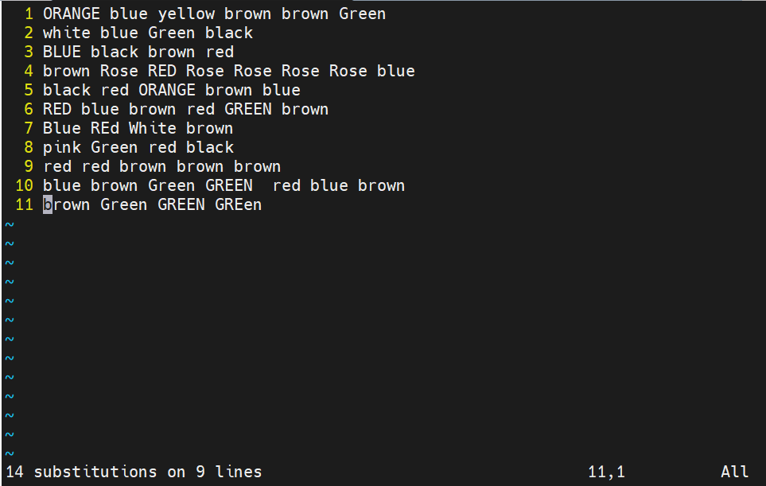

- Execute the command : esc:3,10s/brown/sky blue/g
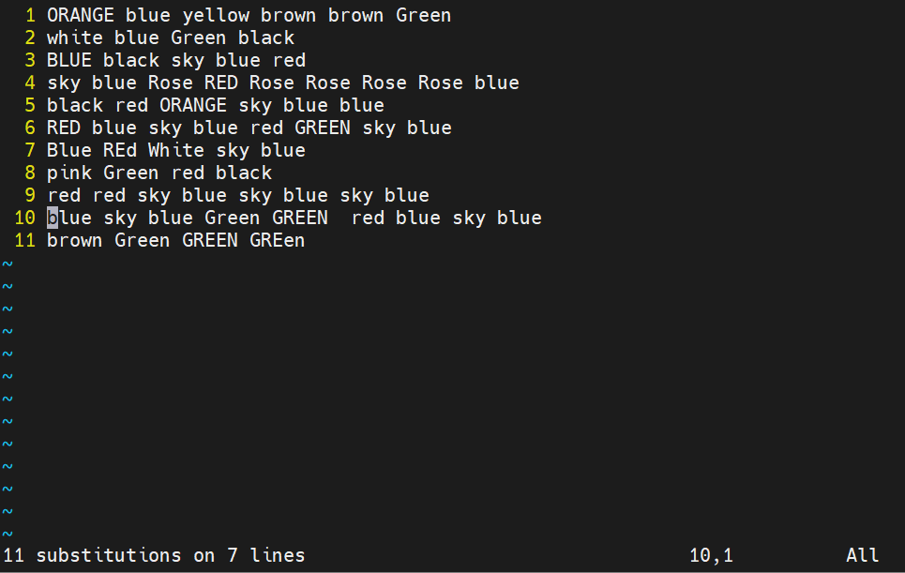

- Execute the command : esc dd [ cursor pointing line will be deleted ]
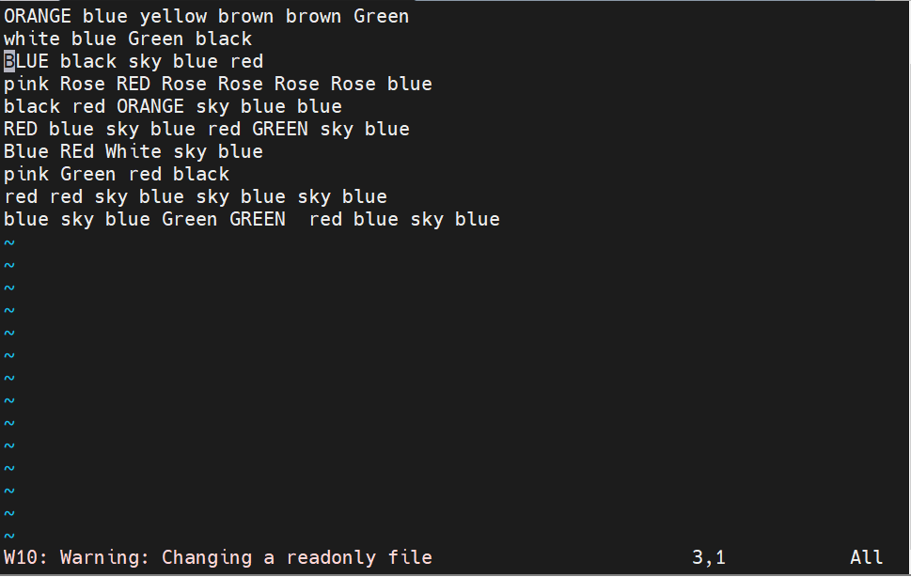

- Execute the command : esc 3dd [delete three lines from the cursor pointing line ]

